Better Call Sauls Series

Dawid Szyszko-Celinski

5/18/23

## Description

Better Call Saul is an American legal crime drama television series created by *Vince Gilligan* and *Peter Gould* for AMC. Part of the Breaking Bad franchise, it is a spin-off from Gilligan’s previous series, Breaking Bad, to which it serves as both a prequel and sequel. Better Call Saul premiered on AMC on February 8, 2015, and concluded on August 15, 2022, after six seasons consisting of 63 episodes.

Set primarily in the early 2000s in Albuquerque, New Mexico, several years before Breaking Bad, Better Call Saul examines the moral declines of *Jimmy McGill (Bob Odenkirk)*, an earnest lawyer and former con artist who becomes the egocentric criminal-defense attorney *Saul Goodman*, and *Mike Ehrmantraut (Jonathan Banks)*, a former police officer who becomes a fixer and enforcer for drug traffickers. Other main characters include Jimmy’s romantic interest and colleague *Kim Wexler (Rhea Seehorn)*, his brother and rival *Chuck McGill (Michael McKean)*, Chuck’s law partner *Howard Hamlin (Patrick Fabian)*, the drug dealer *Nacho Varga (Michael Mando)*, the drug lord *Gus Fring (Giancarlo Esposito)*, and the cartel enforcer *Lalo Salamanca (Tony Dalton)*. In addition to the primary storyline, Better Call Saul includes black-and-white flashforwards set in 2010, after the events of Breaking Bad, which explore the consequences of Saul’s eventual partnership with the drug lord *Walter White (Bryan Cranston)*.

## 2 Photo

## 3 Statistics

```{r}  
stats <- data.frame(season = c(1,2,3,4,5,6), avg.view = c(3.21,2.16,1.64,1.49,1.37,1.27))  
summary(stats)  
```

season avg.view   
 Min. :1.00 Min. :1.270   
 1st Qu.:2.25 1st Qu.:1.400   
 Median :3.50 Median :1.565   
 Mean :3.50 Mean :1.857   
 3rd Qu.:4.75 3rd Qu.:2.030   
 Max. :6.00 Max. :3.210

## 4 Graph

```{r}  
plot(stats)  
```

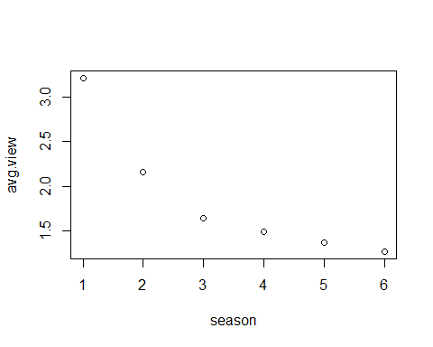

## 6 Decrease

```{r}  
views1 <- 3.21  
views3 <- 1.64  
diff <- views1 - views3  
```

In a first season there were 3.21 M views on average, on season three 1.64 M views on average and difference between seasons 1.57 M views.

## 7

# ASSIGNMENT

# Lists

#### Ordered

1. Item 1

2. Item 2

2. Item 3 # Note the error in numbering

1. Item 1
2. Item 2
3. Item 3 # It's fine here though

#### Unordered

* Item

* Another item

* Item
* Another item

#### Subitems

1. Item 1

- Item 2

- Item 3

1. Item 1
   * Item 2
   * Item 3

Pick a TV show that had its premieres on TV and thus has some viewership numbers reported on Wikipedia. E.g. [Suits](https://en.wikipedia.org/wiki/List_of_Suits_episodes) (see table just above the References)

Then create a short report (you can copy the content from Wikipedia or other pages for this task) that contains, for example:

(do a commit after each step!)

1. A brief description of the show (use *italics* for names).
2. A photo with the logo or a shot from the show itself.
3. A summary of some basic statistics (e.g. on viewership or ratings).
4. A graph of the viewership over time.
5. A graph of the episode-to-episode (or season-to-season) changes in viewership.
6. A short description of the observed changes that includes inline references to numbers (e.g. the viewership decreased by insert_calculated_number between seasons 3 and 5).
7. Make sure your report looks nice -> this time we’re mostly interested in the output and not necessarily the codes used to achieve it.
8. render your report and save it in the relevant folder of your repo.
9. Commit the changes and push them to Github.